- Builsheet location:
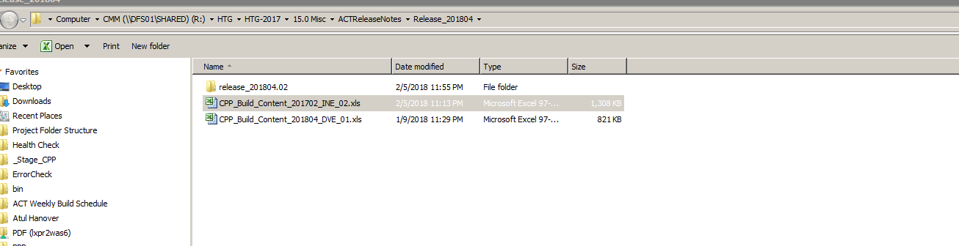

- Starting prep work by running debug.bat file (32 bit machine)

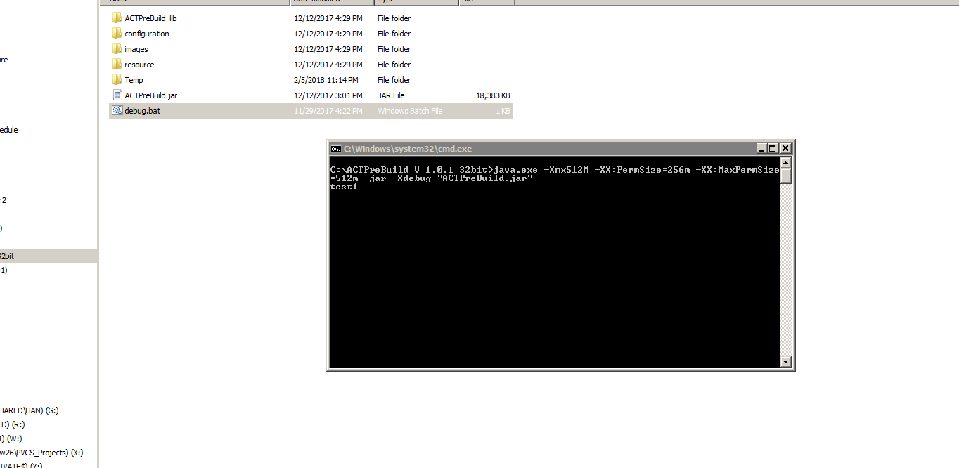

- Execute the builsheet by navigating to the buildsheet path:

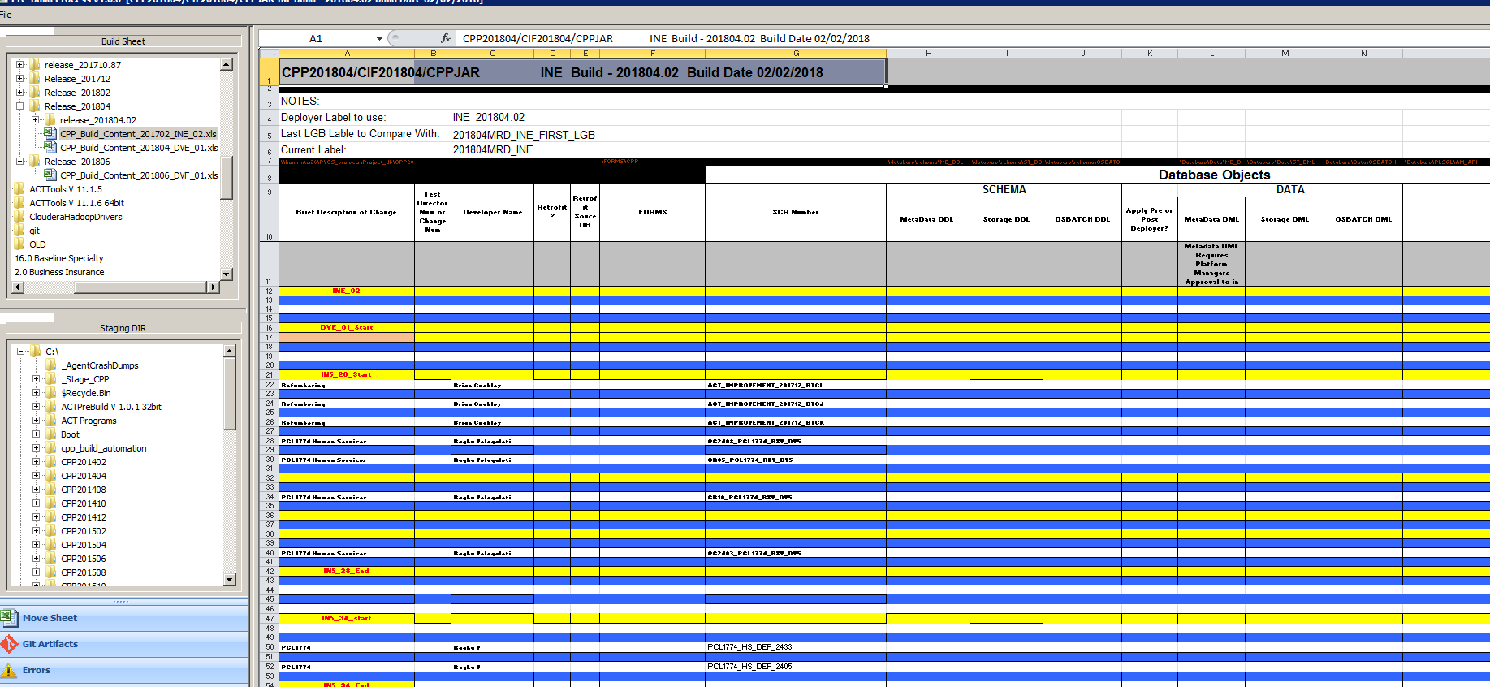

- After completion goto _Stage_CPP folder -> an artifacts folder will be created:

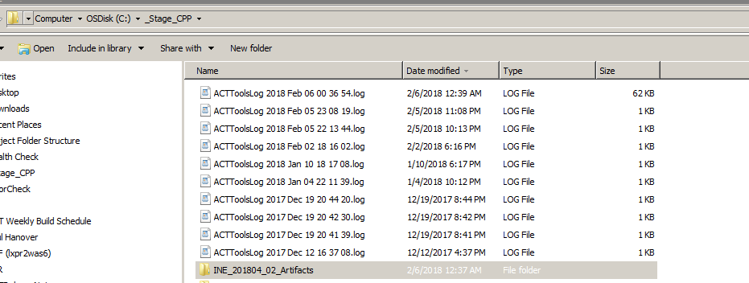

- Execute MK_MD_Lable file to create label in dragon designer:
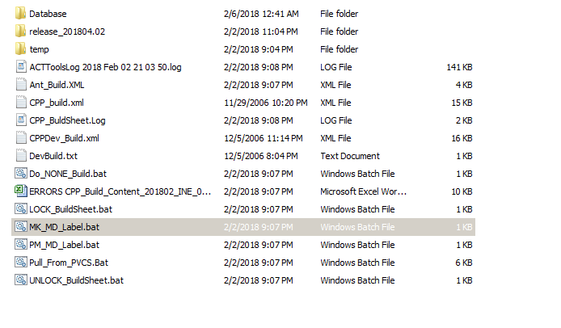
- Execute PM_MD_LABEL file to promote the label created in above step:
- Check the GIT components fetched from GIT under Database folder.

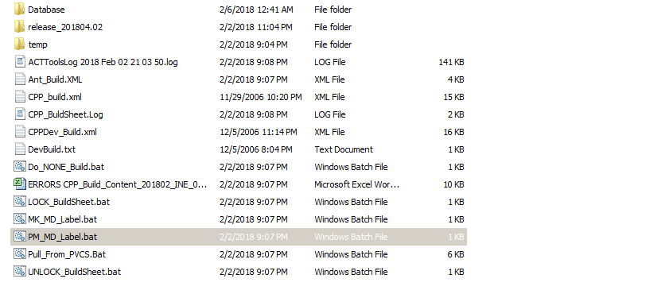

- Goto dragon designer -> Label Management -> Filter out the label -> Click on settings button -> deploy to generate deployer scripts.
- The deployer and history scripts will generate in a zip folder which will be present in your downloads location.
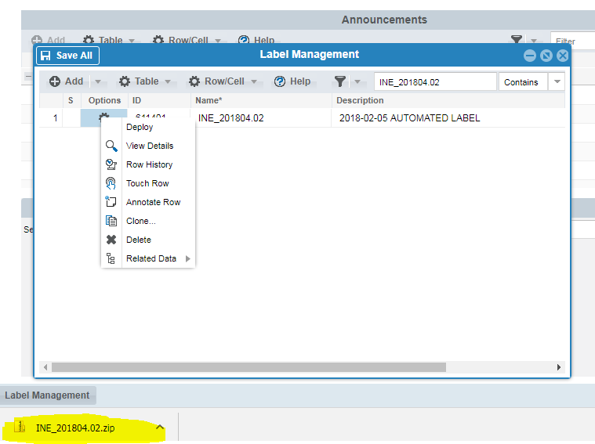

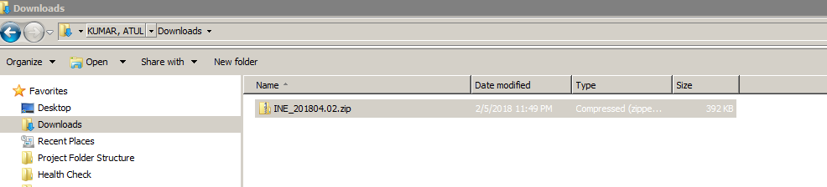

- Extract the files under same location i.e downloads
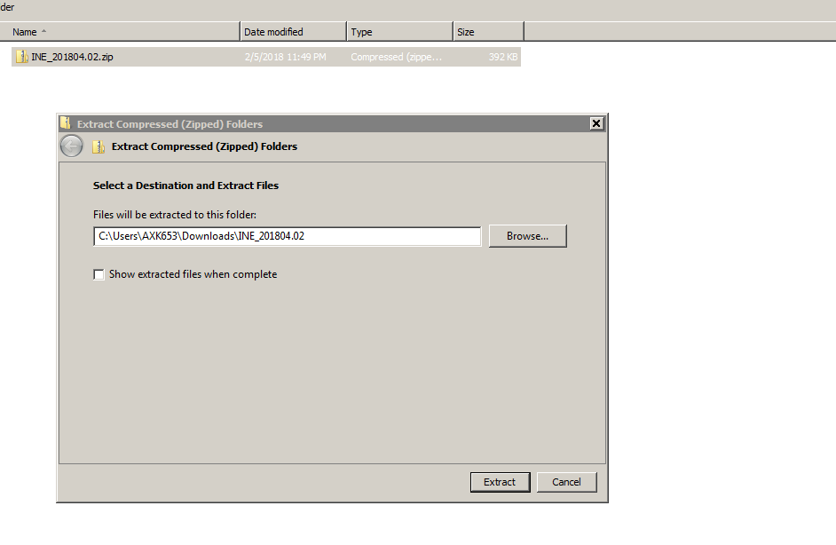

- There will be 5 files generated -> we require only 3 files
- INE_201804.02_SQL_MD.sql -> Deployer script
- INE_201804.02_SQL_MD_HISTORY.sql -> History script
- INE_201804.02_LOG.sql -> Log file
- These 3 files will be provide to ECM team after renaming.

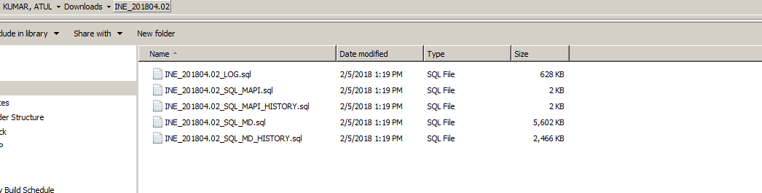

- The final release folder will look like this including ( GIT Components+ Deployer Script+History Script+Log file )

